History of hypnotism and Stage Hypnosis
Introduction
Hypnosis is an often discussed topic in the present day as it has come a long way from being a mysterious phenomenon to a commonly practiced method of pain treatment as well as a publicly performed act. It is indeed interesting to learn about the evolution of hypnosis and study its many interesting features.
The history of hypnosis
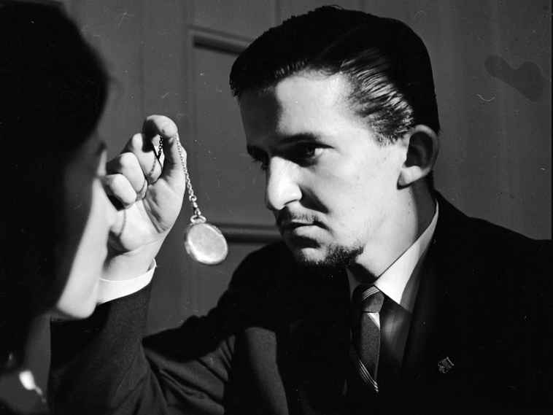
Hypnosis has been in existence since the early civilizations. It had been mainly associated with religious ceremonies where the minds of people were put into a state of rest and peace through a chant or slow beating of drums. “Sleep temples” or “Dream temples” were common in Egypt and Greece where people would visit those places during times of sickness in order to heal themselves. These places are believed to have used hypnosis as a healing method. Evidence of hypnosis are found in the ancient papyrus on Egypt about priests getting patients to fix their mind on certain objects in order to make them enter a trance and treat the mind in the process. Sanskrit books found in India have showed that different levels of hypnosis such as “sleep-walking”, “Ecstasy-sleep” and “Dream-sleep” were practiced by priests and physicians in the ancient times. Hence different sources provide enough evidence to prove that hypnosis dates back to the ancient civilizations regardless of it being considered by some as an innovation or experiment that was born during the New Age movement.
What does hypnosis mean?
The word “hypnosis” derives from the Greek word “hypnos” which means “sleep”. The belief that hypnosis is a state of being unconscious or necessarily asleep (without having control over most of your senses) may have caused the prehistorians to call it “sleep”. Even in the modern day the widely believed conception is similar and has hence induced an unwanted sense of fear over the practice. This article will address those concerns and clarify them as well.
During the time period ranging from the 1600-1800 hypnosis has been performed on animals as experimental purposes as well as getting chores done in farms. French farmers are said to have used hypnosis to influence animal behavior such as calming farm animals. There have also been various hypnotists who travelled from town to town with a set of animals who will be hypnotized on stage. One such hypnotist was Charles Lafontaine who was a known French “magnetizer” who hypnotized animals on stage as well as people. He would call one of his audience on stage and make him enter a trance and these performances would have great success. Lafontaine’s animal magnetism performances had been the major influence for James Braid to focus his studies on magnetism which would later be known as hypnotism. He is said to have taken a great interest in the results of the stage performance of magnetizing a lion and had been determined to find out the truth of it using his own experimentation. He conducted experiments on his wife and servants and found out that fixation of the gaze could have mesmerizing effects which would be caused through the paralysis of nerve centers. This led to his writing of the book “Neurhypnology”in 1866, which included his theories on hypnosis which he specifically differentiated from magnetism and introduced as a new branch.
Dr. Franz Mesmer was another important contributor to the study of hypnosis as he brought up the theory of “mesmerism”. His theory was based on the finding that a universal fluid which existed in our bodies which caused the magnetism. He used magnets to disrupt the gravitational tides which were believed to be negatively affecting his patient’s bodies. He conducted magnetism on many patients and some of the cases were notable achievements of that era, which brought him recognition and fame. Although some of them led to his career being tarnished with scandals, his theories were accepted by a considerable amount of scientists and enthusiasts. His studies and findings have paved the way for many more people to experiment on people as well as animals and form theories with more concrete evidence.
Mesmer was also fond of performing in front of mass crowds and creating results which would stun his audience. His background setting created an ethereal effect with eerie music and the sights of his hypnotized patients. He had also been able to create the image of the confident and mysterious magnetizer who would dress in long black cloaks which would give the impression of a magician more than a healer. This effect may have had an influence on the current beliefs on hypnotism as well.
However with the downfall of Mesmer’s theories some of which were considered obscurities, several physicians took up the challenge of studying the subject from a medical point of view which did not always have a positive effect on their careers. Dr. John Elliotson was one such person who risked his professional reputation in order to conduct experiments and research in this highly speculated and scandalous area. Being the chairman of the Royal Medical and Surgery Society, he resorted to study magnetism and its medical uses, especially in terms of its impact on the nervous system. He was most famously criticized for conducting surgical processes on patients who he kept under magnetism. His objective of conducting such surgeries was to experiment on the pain alleviating abilities of magnetism. He went on to begin a hospital which would conduct surgeries under hypnotism and many physicians and surgeons gathered around him to conduct more research and experiments on the matter. It was during this time that James Esdaille opened up a clinic in India where he performed surgeries under hypnotism with prominent witnesses present in the events. He was able to take the medical situation in India by storm as so many rich and well off patients came forward to cure several of their tumors and severe illnesses with the use of surgery. This gave him fame as well as recognition and he was able to perform almost two thousand operations on Indian patients alone.
While surgeons like Esdaille and Elliotson played their part in proving the medical and surgical uses of hypnotism, James Braid was able to conduct his research and experimentation based on animal magnetism as explained earlier. It was the combined effort of these physicians and surgeons that highlighted hypnotism in the 19th century as a medical technique as well as removing the magical and fantastical elements which were created by the previous physicians. The 19th century saw the birth of hypnotism close to what we know it as today, and the credit must go to the afore mentioned people.
Transition of approach and perception of hypnosis
The 20th century saw many changes in the subject of hypnotism as well as the approach taken by physicians and scientists to demonstrate its effects. Hypnosis had been largely known as a display of some sort which was conducted publicly to attract the attention of the public and create controversy. This had always been supported by the physicians who practiced it publicly, giving the impression of a magician who can give instructions and make people do certain things while in a trance. However this approach also saw some change during this time period as several physicians adopted a different way of performing hypnosis on patients. The commonly known mystical figure who would give instructions to patients changed into a person who would use suggestive language to transform his hypnotized patients to different trances. Milton Erickson was one of the main therapists who inducted this type of approach.
Erickson used suggestive language as well as strong and vivid communication to create a clear image inside the mind of the hypnotized patient. He would believe in creating a lasting image in the mind of the hypnotized patient through clear instructions about physical actions. He broke away from the traditional authoritative nature of hypnotism and created an approach where he would enter into a conversation with a patient and get in strong messages to his mind while he is in a trance. It is this form of conduct that we see in the modern day hypnosis today where a doctor would slowly and subtly guide the patient in hypnosis to focus his mind’s power on something or ponder on something in order to revive a memory or learn to control his actions. It was this approach which gave way to hypnosis being used as a method of relieving patients of psychological distress rather than being used as lab experiment specimens.
Sigmund Freud worked together with Hyppolite Bernheim who was a professor from the University of Nancy and came up with the finding that hypnotism created a certain cortical activity in the brain which created space and opportunity for suggestions to be considered. Freud was able to use hypnotism on a patient called Anna while treating her for hysteria. Freud came up with theories about the cause of hysteria in people and how welled up emotions and thoughts would result in patients losing control over their thoughts and emotions and resorting to hysteria and imbalance in the emotional resistance system. Freud believed that letting out the negative emotions and suppressed frustrations from the system of the patients was a faster way to curing the patient permanently. He linked the cause of hysteria to sexual assaults and experiences as well but later gave up on the theories and focused on dream interpretation instead.
Emile Coue was a pharmacist who studied about hypnotism in the 1930s. He was interested in how suggestive language could affect the hypnotized mind of a patient and went into the extent of finding out that not only did the suggestion work out, but if you give several options to a patient, the mind will be able to choose the best solution along with time and practice. This led to the initiation of psychosomatic medicine in the US, which was able to cure various illnesses such as hysterical disorders, neuropath disorders, menstrual disorders, neuralgia, obsessions, influenza, tremors, spasms and many other physical as well as psychological illnesses through the use of hypnosis. Hypnosis was used during the war era to aid soldiers in times of stress where they would be hypnotized and calmed down in order to have a clear mind in the battle field and during their training. Though it was not the most accepted method of healing, the many instances of soldier healing experiences gave hypnosis the credit it deserved and was considered a reliable method by many.
While hypnosis has changed its approach and results along the way, today it has become a greatly used and practiced procedure in healing as well as display. It is used as an extremely effective method of healing for depression patients as well as people who need to overcome stressful situations as well as illnesses. While it helps people all over the world medically, stage hypnosis is also being conducted in a major way.
Stage hypnosis
Stage hypnosis is most often considered a fraud or a scam while some parties point the finger at these kinds of performances as unethical. Most of the criticism comes from the widely believed impression that hypnosis causes paralysis of the mind and senses and that it causes patients to go into a trance which will put them in a state of vulnerability which will give advantage to their physician/doctor to make them do what the doctor wishes. This is a false belief which must be eradicated as hypnosis does not mean you lose control of your senses or mind. Hypnosis does not put a person into sleep as they are perfectly conscious even though not as active and animated as they might be when they are wide awake. The brain will be more sensitive to suggestions during this time and the therapist will be able to make the patient understand certain notions and ideas by sending suggestion waves to their brain effectively. There is no manipulation involved in a stage hypnosis as only fully grown adults are allowed and signed up for stage hypnosis sessions and they are fully aware of how the programme will be conducted. Hence the false impressions and prejudices must indeed be cured in order to open our eyes to the concept of stage hypnosis.
Stage hypnosis begins in the 19th century as discussed in this article afore and the practice has continued throughout the ages with the same level of speculation and doubt and interests all culminating together. Today, we find many performances all over the world and mainly in the US where we still find ourselves as the audience watching a group of people or one person being hypnotized on stage by a therapist and marvels happen with the conduct of the therapist. There are several new innovations in this area in the present day and some of them are as follows.
Hypnosis for entertainment in the modern day
Hypnosis for entertainment can mostly lead to it being considered as a fraud or give an irrelevant impression of the whole procedure. People are made to believe that the hypnotist can completely control the mind of the patient and made to do anything that the therapist suggests. What must be understood is that there is a major difference between clinical hypnosis and stage hypnosis as clinical hypnosis focuses completely on the benefit of the patient which will be done through a therapeutic process while stage hypnosis is merely meant for the entertainment of the audiences. The people who will be hypnotized will mostly always be volunteers who have already made up their minds to be completely hypnotized and hence through that gain attention for themselves on stage. While part of the volunteers could be thinking in this line of thought, the rest could be taking it as a test or an experiment and could be testing themselves. Regardless of the intention of the patients, the excitements of being on stage and being the subject of attention can always have an impact on the senses of a person and hence may not bring about the best results.
Comedy hypnosis shows
Comedy hypnosis shows are mainly fun-filled performances where hypnosis will be tastefully delivered by a therapist in order to entertain the audience. It is a fast paced performance which focuses on getting the audience to participate in the show and gain a fun experience out of it. Volunteers will be called on to the stage by the hypnotist and they will be gradually hypnotized in to a natural trance while the rest of the audience watches. The therapist will then make them do certain comical things in order to make the audience laugh. Things like jumping up and down in joy or running after an imaginary cat or a ball or talking to someone with eyes closed would be some of the commonly performed “suggestions” by most of the hypnotists of comic hypnosis shows. It will solely be done to have a fun and enjoyable time without offending anyone or making anyone uncomfortable. The ability of the therapist to make the audience enjoy and get even the most moody people in the audience to laugh out loud to the performance on stage will decide if the event is a success and whether it will attract more numbers of people to the next shows. This has become a very popular entertainment event lately as it does not cause any negative impact on people or any organization and is solely based on the idea of hypnosis and used as a technique to make people laugh and have a good time.
As discussed and explained above, hypnosis has begun mostly as a religious practice in the ancient times and developed into a more of a display of clinical methods which were able to cause many controversies and doubts in the minds of the people. With the fast developments in medicine and medical and surgical procedures, hypnosis has been able to receive both positive and negative comments from the general public as well as experts. However along with the prejudices it has against it and the enigmatic effect which binds scientists minds to it have been able to make hypnosis a majorly discussed topic in the world today and it will continue to be in the future as well. It has become a great way to heal illnesses physically as well as mentally and become an aid for psychological students and therapists to further their researches and experiments successfully. While it has its medical values and uses, the entertainment industry has also made use of the concept of hypnosis and its history of display and public performances a tool to create something fun and enjoyable out of it. Hence we see different forms of entertainment in the name of hypnosis being performed publicly in the United States as well as other parts of the worlds. Being a hypnotist comedian has also gained popularity as the profession is highly enjoyable and easy to train and practice.
Hypnosis has certainly come very far in the world and with the continuous development in technology, mankind will no doubt be able to conduct more experiments on the subject and keep on finding new ways to explore the many capacities of the human brain and the nervous system. Hypnosis has only been one branch or avenue that has paved our way inside the amazing creation called the human system but in the near future we will be able to read and experience more insights and detail into the human system. Science has still got a long way to go and with more research on neuroplasty, hypnosis will definitely open up new doors to learn more about controlling the mind and more importantly, how to use the brain and its stimuli in the healing process.
As Buddhism and several other religions preach the power of the human mind is still an enigmatic phenomena which science has still not unraveled completely. But I do believe that we are gradually getting there and hypnosis and the many avenues it opens up for us will ultimately take us to the correct destination.

